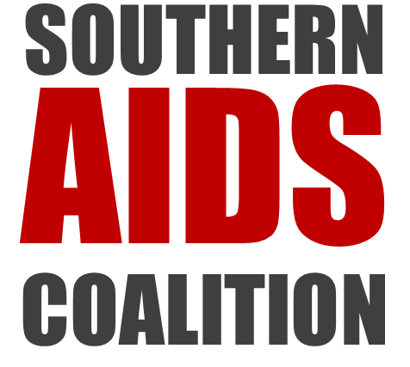


Dear Advocate:

The Centers for Disease Control and Prevention (CDC) recently decided to restrict eligibility for direct HIV prevention funding to community-based organizations (CBOs) located in a limited number of urban areas. As a result, the South, a region that has experienced disproportionately high HIV diagnosis and death rates, has lost critical funding. For example, under the CDC’s new funding announcement, 27.5% of people living with HIV in Tennessee live in areas ineligible for funding.

Call to Action

We are collecting letters to send to Dr. Eugene McCray, Director of HIV/AIDS Prevention at the CDC, from concerned individuals, including people living with HIV, friends and family, and advocates. We encourage you and your organization to assist in this effort by collecting letters from your stakeholders.

You can find our CDC Funding Inequities Toolkit on our website. (http://southernaidsstrategy.org/cdc-advocacy-toolkit-for-texas/) The Toolkit includes materials to assist you in this project:

- Fact Sheet on the Impact of Recent CDC Funding on Southern CBOs.
- Fact Sheet on how the CDC funding gap impacts your state.
- PowerPoint explaining the funding announcement, the effect on your state, and our letter writing campaign
- For more information, a detailed report analyzing the CDC funding announcement: Carolyn McAllaster & Jerry Fang, One Size Does Not Fit All: What Does High Impact Prevention Funding Mean For Community-Based Organizations in the Deep South? (2015),

In addition to the attached materials, you will need to provide stationery and envelopes to your constituents. Once you have collected your letters, please send us your letters by May 1, 2016. Our address is:
Southern HIV/AIDS Strategy Initiative
Duke Law School, Box 90360
Durham, NC 27708.

If you have any questions, please feel free to reach out anytime. We look forward to your participation in this important campaign.

Carolyn McAllaster Nic Carlisle
Southern HIV/AIDS Strategy Initiative Southern AIDS Coalition
mcallaster@law.duke.edu nic@southernaidscoalition.org

