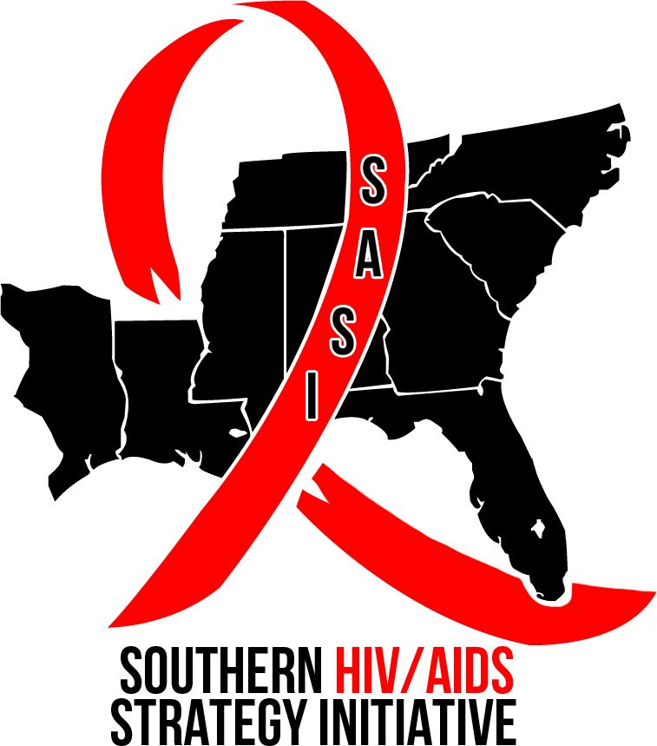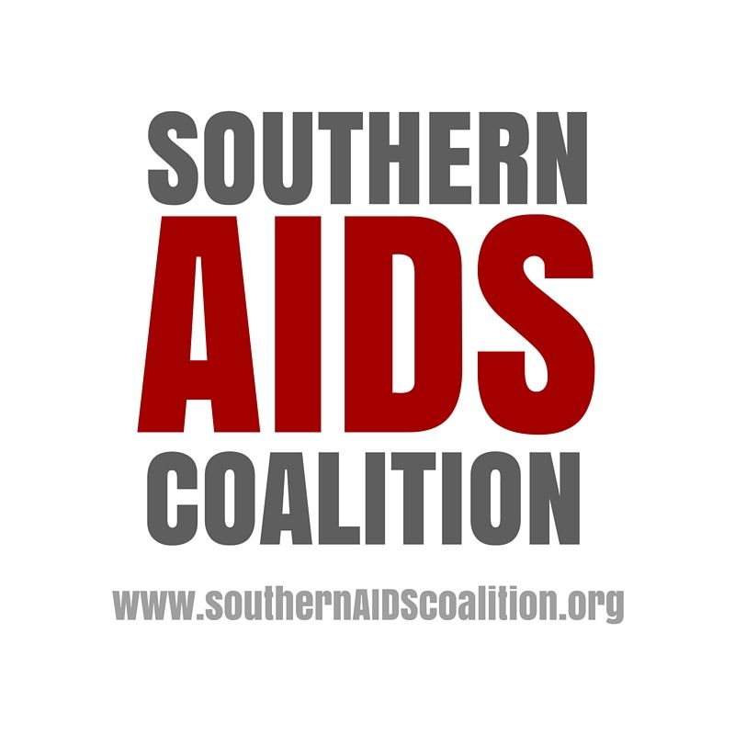

SOUTHERN PATHWAY WORKSHOPS AT USCA
WORKSHOP #1
Workshop Title: Southern Stigma: New Research; Positive Action
Date/Time: Friday, September 8th; 4:15 – 6:15 p.m.
Location: Treasury, Meeting Level 4
Presenters:
- Susan Reif, MSW, PhD, Research Associate, Duke University Center for Health Policy, Durham, NC.
- Meta Smith-Davis, Coordinator for PLWHIV Stigma Index Project, Assistant Director of Prevention, HAART, Inc., Baton Rouge, LA.
- Venita Ray, JD, Public Policy Manager, Legacy Community Health, Houston, TX.
- Larry L. Walker, Co-founder of THRIVE SS, Inc., Atlanta, GA.
- Gina Brown, Community Organizer, Southern AIDS Coalition, New Orleans, LA. (moderator)
Description of the Workshop:
The disproportionate burden of new HIV cases in the South is further exacerbated by the need to respond within stigmatized surroundings. Pervasive internal and external stigma in the US South creates additional barriers toward achieving optimal health. In this workshop, participants will hear about the latest stigma research coming out of the Deep South, including the results of the Southern HIV/AIDS Strategy Initiative’s Stigma Study and the results of the PLWHIV Stigma Index Project in Louisiana. These studies describe HIV-related stigma in the Deep South and report some of the negative effects of stigma on health outcomes. Our presenters will also describe on-the-ground initiatives that empower PLWHIV and fight stigma, including the Undetectables Model from Atlanta, GA, and the Positive Organizing Project from Houston, TX. The workshop will be interactive, engaging the audience in a discussion of HIV-related stigma and initiatives that have been successful in combatting stigma.

WORKSHOP #2
Workshop Title: Using the Law to Discriminate, a Southern Perspective
Date/Time: Saturday, September 9th; 9:00 – 11:00 a.m., Treasury Meeting Level 4
Presenters:
- Kathie M. Hiers, CEO, AIDS Alabama, Birmingham, AL
- Venita Ray, JD, Public Policy Manager, Legacy Community Health, Houston, TX.
- Nic Carlisle, JD, Executive Director, Southern AIDS Coalition, Birmingham, AL
- Carolyn McAllaster, JD, Clinical Professor of Law, Director Southern HIV/AIDS Strategy Initiative (SASI) at Duke Law School, Durham, NC. (moderator).
Description of the Workshop:
Stigma has always been a challenge for both persons living with HIV and for service providers in our country. Misguided efforts by policy makers to criminalize HIV or to legislate religious values are far too common, and the South is experiencing a growing number of these unfair laws based in ideology, not science. Learn specifics about these proposed and passed statutes, as well as successes in defeating them in our southern states. Advocates must remain vigilant and proactive in recognizing this trend and in stopping these discriminatory laws before they negatively impact lives.

WORKSHOP #3

Workshop Title: The Intersection of Racial Justice, Mass Incarceration and HIV in the South
Time/Date: Saturday, September 9; 4:15 – 6:15 p.m., Treasury Meeting Level 4
Presenters:
- Charles Stephens, Counter Narrative Project, Atlanta, GA (Moderator)
- Vanessa Johnson, JD, Ribbon Consulting Group, LLC/PWN-USA, Washington, DC
Washington, DC
- Marvell Terry, II, The Red Door Foundation, Memphis, TN
- Megan McLemore, Human Rights Watch, New York, NY

Description of the Workshop:
As we move into the fourth decade of the AIDS epidemic, the South now has the distinction of being the center of the epidemic because it has the highest rate and prevalence of HIV and AIDS of any other region in the US. Also, the South has the highest incarceration rates in the country. There is no coincidence that African Americans, trans women of color, and gay and bisexual men and youth of color are disproportionately at risk for both incarceration and HIV. The goal of the workshop is to discuss how broader issues of racial justice and mass incarceration continue to fuel the epidemic in the South. This workshop will explore the historical underpinnings of the criminal justice system and its design to control and oppress communities of color. We will discuss ways that organizations can work more effectively at this intersection by centering their work on racial justice, criminal justice reforms, human rights and economic justice.

WORKSHOP #4
Workshop Title: Southern Salvation: Black Gay Men, HIV, and the Black Church
Date/Time: Sunday, September 10, 9:00 – 11:00 a.m.
Presenters:
- Shanell L. McGoy, PhD, MPH, HIV/STD Director, Tennessee Department of Health
Nashville, TN
- Khafre K. Abif, Community Organizer, Southern AIDS Coalition, Atlanta, GA

- Mardrequs Harris, Senior Program Analyst, National Association of County and City Health Officials, Washington, DC

Description of the Workshop:
For generations, the Black Church has been a leader for change in the Black community on issues of social justice, including voting rights and employment opportunities. For many families, the Black Church is also the epicenter of faith, community, and understanding. Instead of reaching out and ministering to Black gay men, however, the Black Church has opted for rejection, ridicule, and condemnation. Where does the Black gay man turn for healing and hope? Who helps to validate him? How has this approach contributed to the HIV epidemic in Black America? We will explore these questions through an interactive session that includes an in-depth discussion about HIV in the Black Church, allowing participants to share personal experiences and discuss strategies for how to successfully enlist faith leaders as change agents in the fight against HIV in Black America.

